Pocket Stars PDA Version 5 Operating Manual
For Windows Mobile Pocket PCs

Introduction
Whether you're navigating across the Pacific, visualizing planetary orbits from your backyard, or looking for a handy reference guide to the heavens, Pocket Stars provides fast and flexible visualization of the solar system and beyond.
Based on data from the Jet Propulsion Laboratory and the US Naval Observatory, Pocket Stars offers extremely accurate positional information for solar system bodies, stars, constellations, and Messier and Caldwell objects.
Targeting astronomers, celestial navigators, and the casual observer, Pocket Stars offers numerous tools for visualization, identification, animation, and computation of position based on celestial observations using a sextant.
Table of Contents

Introduction 1
Features 2
Install Pocket Stars PDA 3
Uninstall Pocket Stars PDA 3
Display Modes 4
2D 4
3D 4
Display Features 5
Tap-and-Hold 5
Controls 6
World Pages 8
Latitude and Longitude 8
Time Page 9
Environment 10
Sextant Page 11
Details Page 12
LOPs Page 13
Graph Page 14
Menu 15
Find Page 15
Info Page 15
Rise Set Page 16
Lunar Phase Page 16
Calculators 17
Great Circle Distance Page 17
Range and Bearing Page 18
Horizon Distance Page 18
Preferences 19
Preferences.General Page 19
Preferences.Colors Page 19

Features
Star Chart Features
- Simple and fast star, planet, constellation and Messier object identification. Single click on any body to get the name, designation, calculated altitude, azimuth, and magnitude. Drag the cursor to scroll the chart. Zoom in and out with a single click.
- 3D Solar system flythrough.
- User location set by GPS, clicking on map, city selection, or by entering Latitude and Longitude.
- Complete user control of colors and skins.
- Orbital paths of inner planets and sun.
- Time Animation.
- Black, white, and red star chart colors for normal, bright, and night viewing conditions, respectively.
- Chart can be rotated to any of the 16 compass points and also flipped along the North - South axis.
- Chart can be "live, realtime", or static for any user selected time.
- Core positional calculation routines based on "Novas" (Naval Observatory Vector Astrometry Subroutines Version 2.0.1) from the US Naval Observatory.
- Star data is from the Bright Star Catalog (5th Revised Edition), comprising the 9110 brightest stars using J2000 equatorial positions and the International Celestial Reference Frame (ICRF). Corrections are performed for proper motions and parallax.
- Planet ephemeris data from Jet Propulsion Laboratory using the DE405 database. DE405 is JPL’s latest planetary ephemeris with correction for both nutations and librations. DE405 uses the J2000 International Celestial Reference Frame (ICRF). The portion of this database provided with Pocket Stars covers the years CE 2000 to CE 2020. Other ephemeris date ranges are available for download.
Celestial Navigation Features
- Reduction from sextant altitude to observed altitude for any of the 9110 stars, nine planets, and sun and moon.
- Corrections for observer height (DIP), refraction (temperature and atmospheric pressure), and vessel movement.
- Position from intercept and azimuth by calculation for multiple sextant observations following procedures in The Nautical Almanac by the United States Naval Observatory.
- Any number of sextant observations can be individually enabled to compute a best fit when computing a FIX. Results may be plotted, showing the assumed position (AP), FIX, and observations with intercepts and amplitudes.
- Intermediate calculations for each observation can be displayed, with selectable formats (DD.dddd, DD MM.mm, DD MM SS) for degrees, minutes, seconds.
Other Features
- Rise, set, and meridian times for all solar system bodies.
- Lunar Phase calendar and animation showing the relative positions of the earth, moon, and sun.
- Images and physical data for planets, moon and sun, Messier and Caldwell objects.
- Great Circle distance calculator
- Range and bearing calculator
- Horizon distance calculator
- Julian Day calculator
- Degree minute seconds conversion calculator

Install Pocket Stars PDA
Pocket Stars PDA is provided in two different formats:
- Installation on a PC using ActiveSync: The file downloaded is named “pocketstars.ppc30_arm.exe”. Run this file on your PC with your PDA connected via ActiveSync.
- Installation without using a PC “Over the Air” (OTA). The file downloaded is named “PocketStarsOTA.exe”. Download this file directly to your PDA and run it in place. This installation circumvents both ActiveSync and using a PC, and is the preferred choice for Linux and Mac users.
- Both installation routes start an installation program which will copy 6 files to your PocketPC. These files can reside anywhere, in any directory, including an external memory card (CF, SmartMedia, etc.), but must all reside in the same directory (except PocketStars.htp which resides in the "\Windows" directory):
PocketStars.exe - the executable
PocketStars.405 - the ephemeris file
PocketStars.40c - cache of daily planet locations for Orbital Paths
PocketStars.htp - help file
PocketStars.psj - a configuration file.
PocketStars.dist - a configuration file.
- When installation has completed, click on Start.Programs.Pocket Stars
- If you purchased the registered version, enter your registration code on the "Menu.Help.Registration" page.

Uninstall Pocket Stars PDA
- Exit Pocket Stars (select Menu.Exit).
- Start.Settings.System.RemovePrograms.
- Select "Nomad Electronics Pocket Stars", and then Remove. This will remove all trace of Pocket Stars from your device.
- Removal of Pocket Stars is quite clean. It installs neither DLLs nor registry entries, so there is no chance of entering DLL hell or creating side effects from either installation or deinstallation.

Display Modes
Pocket Stars offers two primary display modes. In 2D mode, you see the sky from a selected point on the surface of the earth. In 3D mode, you can position the viewpoint anywhere within the solar system.
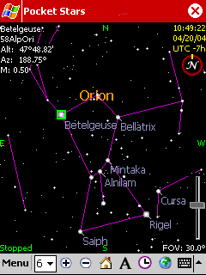 |  | 2D When Pocket Stars starts up, it displays an overhead view of the sky. This is called the "2D Star Chart" mode.  To select a single body or star simply click on the screen. A green square is drawn to highlight the selection, and live measurements of the calculated altitude (Hc) and azimuth (Az) are shown in the upper left corner along with the magnitude (M).  To scroll the sky, just drag the selection.  To zoom, use the plus and minus magnifiers or use the fast zoom slider at the lower right.  The home button repositions the viewing point to directly over the users position, removing all pan and scroll effects.
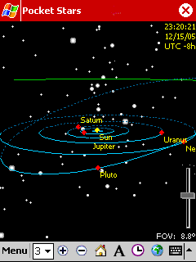 |  | 3D Select "3D Orrery" mode from the menu to view the entire solar system and background stars and constellations from any point in the solar system.  In 3D mode, drag the screen to rotate the entire solar system.  The zoom controls are used to set the viewing distance from the sun.

Display Features
Both 2D and 3D modes share a number of common display features.
- Selection.TopLeft – Realtime information on the selected object.
- Time.TopRight – Shows the time for which the star chart is valid. Note that if the star chart is not realtime, the time color changes to yellow as a warning.
- Calculation.BottomLeft EShows the state of the starchart, such as stopped, animating, or calculating.
- FOV.BottomRight Shows the field of view.
- ZoomSider.BottomRight rapidly changes the zoom setting.
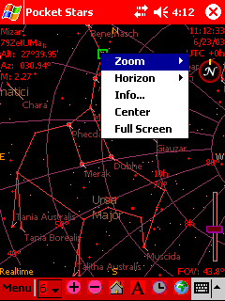 |  | Tap-and-Hold  If you tap-and-hold on the star chart, a menu is displayed showing frequently used options which affect the chart presentation.  - Zoom - select from a number of common zoom settings.  - Horizon - select a horizon to view or the zenith.  - Horizon.Flip East-West is used to mirror the star chart vertically, switching the position of East and West. When viewing the screen overhead, in line with the stars, leave this unchecked. When viewing the chart with the screen on a tabletop, check this item.  - Info... Show information about the selected object.  - Center - center the selected object on the screen.  - Full Screen - Remove the title bar at the top of the screen to increase the star chart real estate.

Controls
Compass Indicates and changes which compass direction is shown at the top of the display. The yellow line indicates North. Click within the red circle and then drag the yellow line to point in the direction of North.
Using this control, you can rotate the star chart 360°.
Star Magnitude Use the Star Magnitude listbox to control how many stars are shown. When first getting oriented, select a low Magnitude number like 2 or 3.
Magnitude | Number of Stars
0 | 4
1 | 15
2 | 48
3 | 170
4 | 513
5 | 1604
6 | 5023
7 | 9046
8 | 9096

Zoom The ZoomIn and ZoomOut buttons let you control the magnification from 1.0 to infinity.

Home The home button removes all scroll and panning effects. The stars shown in the green "X" at the center of the screen are directly overhead.

Objects Displays a dialog controlling the objects to display on the star chart. Independent selection lists are maintained for 2D and 3D viewing modes.
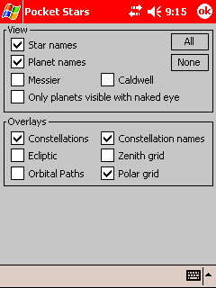
Hint: Orbital Paths are compute intensive and will decrease the speed of animation in 2D mode.
 |  | Clock Displays a menu controlling time and animation
 |  | By Minute  By 10 Minutes  By Hour  By Day  By Week  By Month | Selects the unit of time used for animation and stepping.
 |  | Step +  Step - | Step one increment of time forward or reverse.
 |  | Animate +  Animate -  Animate Stop | Continuously animate time forward or reverse or stop animation.
 |  | Realtime | Keep star chart synchronized with the device clock.
 |  | Select... | Select a particular time.

World Pages |  | The World Pages are accessed by the Globe Icon.
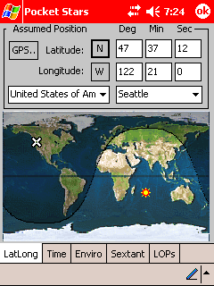 |  | Latitude and Longitude  The LatLong Page establishes the central viewing point for the sky as well as the Assumed Position for sight reduction calculations using a sextant.  There are four different ways to select your position. You can drag the cursor over the world map, select a country and then a city from the listboxes, enter your position in degrees, minutes, and seconds, or click on the GPS button to set your location via a GPS receiver.  The first 4 entries in the city list are "Custom", user programmable locations which are retained across invocations of Pocket Stars. You can edit the text designation ("My Backyard") and set Lat/Long either via clicking on the map or manually entering the coordinates.  The map also displays the position of the sun and portions of the world in daylight and night.
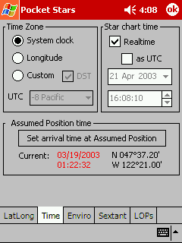 |  | Time Page  The Time Page is used to set the Time Zone as well as two different time values.  Time Zone contains three options for controlling the local offset from UTC (Coordinated Universal Time).  DST is a checkbox which specifies whether Daylight Savings Time is in effect. This control is only enabled for the Longitude and Custom methods of controlling the Time Zone.  Realtime specifies that the clock in your Pocket PC is used to set the star chart time when checked. If this control is not checked, you can select a different particular time, and the star chart is static.  as UTC specifies that the time fields are in Coordinated Universal Time rather than local time.  Set arrival time at Assumed Position should be selected to specify the time when the vessel was at the location set on the LatLong page. This step is only important when calculating a celestial navigation fix on a moving vessel.
  - The time to use for the star chart.
  - The time a moving vessel arrives at the Assumed Position set on the LatLong page. This value is only used for celestial navigation on a moving vessel.
  - System Clock - use the time zone specified by the device clock. This is controlled by "Start.Settings.System.Clock".
  - Longitude - Uses the current geographical location (specified in the LatLong page) to calculate Zone Time. While correct for many locations, this method does not take into account the effect of political boundaries.
  - Custom - Enables a list box to manually set the Time Zone.
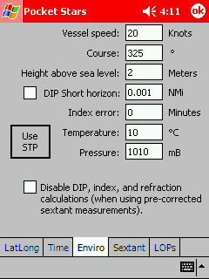 |  | Environment  The Environment Page describes the local environmental conditions of the observer. Although these settings will slightly modify the star chart display, they are mainly used when performing a celestial navigation fix.  Vessel speed and Course describe the movement of the vessel.  Height above sea level sets the observation height of the sextant.  DIP Short horizon allows observations to be made when the true horizon is not visible. If you know the distance to a shoreline or other fixed body, check this box and enter the distance in nautical miles to the shoreline.  Index error sets the instrument error of the sextant in minutes of arc.  Temperature and Pressure set the local conditions which affect atmospheric refraction.  Use STP stands for "Use Standard Temperature and Pressure", which resets the Temperature and Pressure fields to their default values.  Disable DIP, index, and refraction calcs (calculations) let's you input pre-corrected sextant altitude measurements.
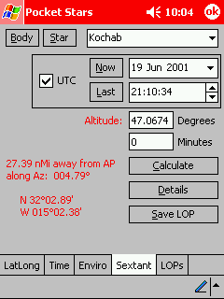 |  | Sextant Page  The Sextant Page is used to perform a celestial navigation sight reduction. Here you can select a body or star for observation, and then input the altitude measured with a sextant (H_{s}).  Body and Star fill the listbox with Bodies and Stars respectively. If you have selected a body in the star chart it will be displayed by default.  Now sets the time fields to the current time.  Last sets the time fields to the last calculated LOP.  UTC when checked indicates that time values are in Coordinated Universal Time rather than local time.  Altitude is where you enter the altitude to the body measured with a sextant. You can enter this as either decimal degrees, or as degrees and minutes.  Calculate performs for the sight reduction for the given body, time, and sextant altitude.  The result is shown in red in the lower left portion of the display as a distance toward or away from the Apparent Position along the Azimuth of the body.  Save LOP saves the current LOP.  Details displays all of the intermediate results for this LOP.  Hint: Clicking on the red Altitude text fills the (Hs) edit box with the approximate calculated values for the selected body. This is just to make data entry easier.  Hint: You can click on the red text to switch the format of the results:  DD° M.MMM' (degrees, decimal minutes)  DD.DDDD° (decimal degrees)  DD° MM' SS" (degrees, minutes, seconds)
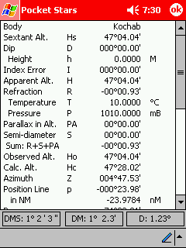 |  | Details Page  The Details Page shows all of the intermediate results used to perform a sight reduction and calculate a line of position.  Hint: You can click on the buttons at the bottom of the page to change data formats:  DD° MM' SS" (degrees, minutes, seconds)  DD° M.MMM' (degrees, decimal minutes)  DD.DDDD° (decimal degrees)
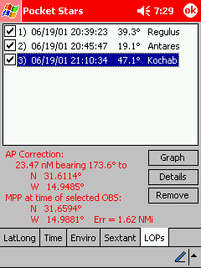 |  | LOPs Page  The LOPs (Line of Position) Page is used to calculate an improved fix from two or more LOPs.  You can select from amongst the previously acquired observations by checking the associated checkbox.  The results are shown in red text in the lower left corner. These include:  - Corrected Assumed Position  - Bearing and distance to corrected AP  - Most Probable Position (MPP)  - Standard deviation of measurement error  The standard deviation of the estimated position (sigma) is expressed in nautical miles. Generally, this value will decrease as the number of observations increases.  Graph draws a graph of the selected LOPs along with the AP and FIX.  Details shows the intermediate results for a particular LOP.  Remove deletes the selected LOP.  The example shown to the left is taken from the Nautical Almanac for the Year 2001 page 283.  Hint: You can click on the red text to switch formats:  DD° M.MMM' (degrees, decimal minutes)  DD.DDDD° (decimal degrees)  DD° MM' SS" (degrees, minutes, seconds)
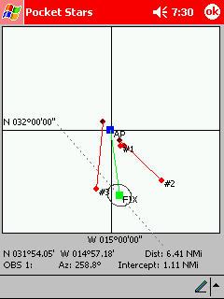 |  | Graph Page  The Graph Page plots the lines of position enabled on the LOP page. The Apparent Position is centered on the screen (the blue square), and the various observations are plotted with the endpoints labeled with the measurement index (the red lines).  The best fit to the measurements is plotted in green, and is labeled FIX.  If a speed and course have been set on the Enviro page, the vessel course is shown as a dotted gray line passing through the fix.  A 95% confidence ellipse is drawn centered on the FIX. The shape of the confidence ellipse depends only upon the number of observations and the distribution of the observations in azimuth. The size of the ellipse depends upon the observation errors.  The example shown to the left is taken from the Nautical Almanac for the Year 2001 page 283.  Hint: You can click on the graph to get the Latitude and Longitude of any point. Clicking near the endpoints of any observation displays the details of that observation at the bottom of the screen.

Menu |  | The following pages are accessed via the main menu.
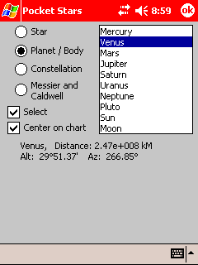 |  | Find Page  The Find Page displays named objects which you can optionally select and position in the center of the star chart.
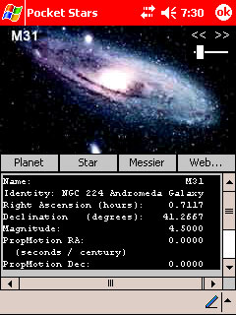 |  | Info Page  The Info Page shows additional information about the selected body. Tap-n-hold on the main star chart to display the Info page.  Press the "Planet", "Star", or "Messier" buttons to display objects of each type.  Press the "Web" button to launch Explorer if connected to the internet to automatically retrieve additional information about the selected object.  Hint: Use the slider control in the upper right corner of the screen to scroll rapidly through all of the bodies. Or use the << and >> arrows in the upper right corner of the screen to decrement and increment by one.
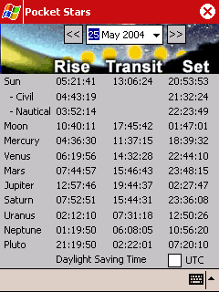 |  | Rise Set Page  The Rise Set Page show the rise, transit, and set times for all bodies.  Select a date using the calendar at the top of the page, or use the << and >> arrows to move a single day forward or back.  UTC switches the display between local time and UTC.  The bottom line displays either "Standard Time" or "Daylight Saving Time" depending on the date selected.
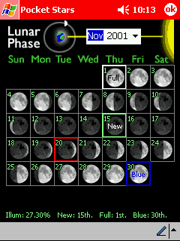 |  | Lunar Phase Page  The Lunar Phase Page shows an animation of the phase of the moon for a month long period.  Select a month to view by using the calendar at the top of the page.  The graphic at the top of the page shows an animation of the relative positions of the moon, earth, and sun (obviously not to scale). If you click anywhere on the calendar, the animation stops and the lunar position is shown for that particular day. If you click outside the calendar, the animated display resumes.  Note that in this month, the display shows a blue moon. The blue moon definition employed here is the "second full moon in a calendar month" version invented in March 1946 and foisted on an unsuspecting world by Sky and Telescope. For a fascinating look at the various definitions of blue moon, look here.

Calculators
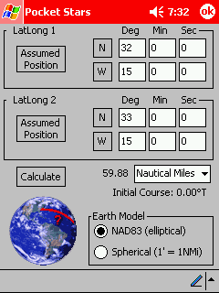 |  | Great Circle Distance Page  The Great Circle Distance Page calculates the shortest distance between two points traveling over the surface of the earth along with the initial course from LatLong1 to LatLong2.  Assumed Position loads either LatLong1 or LatLong2 with the current Assumed Position.  Calculate performs the great circle distance calculation and initial course. You may select output units of NMi, statute miles, and kM.  Earth Model specifies the shape of the earth used in the calculation.  Spherical assumes a perfectly uniform, spherical earth where 1' = 1NMi.  NAD83 (North American Datum of 1983) is an earth-centered datum based on the Geodetic Reference System of 1980. The size and shape of the earth was determined through measurements made by satellites and other electronic equipment; the measurements accurately represent the earth to within two meters.
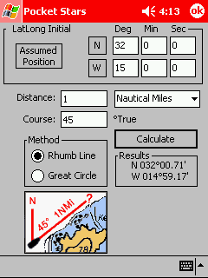 |  | Range and Bearing Page  The Range and Bearing Page calculates resulting LatLong given a starting point, along with a range and bearing.  Assumed Position loads LatLong Initial with the current Assumed Position.  Distance may be expressed in either NMi, statute miles, or KM.  Course is expressed in degrees true.  Method allows selection of either "Rhumb line" (constant compass bearing) or "Great Circle" methods of computation. Both methods will give identical results for short distances and angles which are multiple of 90°.  Calculate performs the range and bearing calculation. The Results window contains the resulting LatLong.
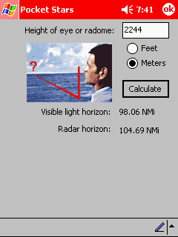 |  | Horizon Distance Page  The Horizon Distance Page calculates the visible horizon for both visible light and radar signals.  Height of eye or radome specifies the eye height of the observer in either feet or meters.  Calculate performs the horizon distance calculation.  Hint: You can determine the distance at which an object of known height will be visible by adding the value to the height of the observers eye.  Example: We're sailing to Tahiti, and wish to know how far away land can be detected. We know that Mount Orohena is 2241 meters high, and our eye height is 3 meters. Enter 2244 meters ( 2241 + 3), which gives the result of 98 NMi.

Preferences
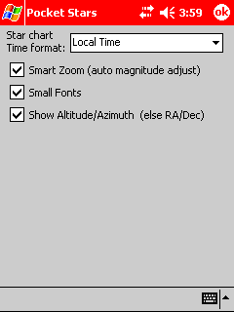 |  | Preferences.General Page  Star chart Time format controls the format in which time is displayed in the upper right corner on the main star chart. Choices are "Local Time", "Local Sidereal Time", "UTC", and "Greenwich Mean Sidereal Time".  Smart Zoom if enabled, automatically sets the star magnitude control on the menu bar as the chart is zoomed in and out to reduce screen clutter.  Small Fonts uses a smaller font on portions of the star chart.  Show Altitude/Azimuth (else RA/Dec) if enabled shows Altitude/Azimuth in the upper left corner of the star chart. Otherwise Right Ascension and Declination are displayed.
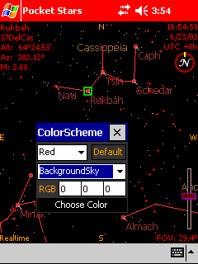 |  | Preferences.Colors Page  Preferences.Colors is used to skin or customize all of the colors used to generate the 2D Star Chart and 3D Orrery display.  Black/White/Red are choices in the first listbox which allows selection between three different color schemes. Each color scheme is independent from the others and can be individually customized.  Default returns the selected color scheme back to the original settings after user confirmation.  BackgroundSky... is a listbox containing the names of all the elements on the star chart. To customize an element, select it in this list, then either:  RGB enter the RGB (Red, Green, Blue) color components for the element (0-255).  Choose Color displays a color selection dialog where a color may be selected for the element.

